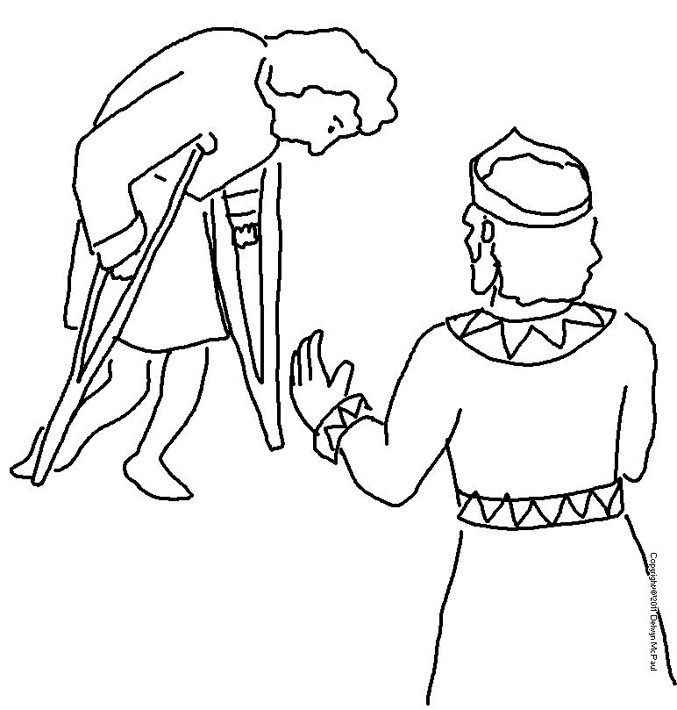

Instead, be _ _ _ _ to each other, tender-hearted,
_ _ _ _ _ _ _ _ _ one another, just as God through Christ has forgiven you. Ephesians 4:32_{NLT}

